Lee Jae-myung
2018.7.1 – Present

Provincial Policy
A New Gyeonggi Province, A Fair Society

Profile
July 2014 – March 2018
Mayor of Seongnam City, Gyeonggi Province

June 2012
Chairman of the Council of Local Government Leaders of the Democratic United Party

July 2010 – June 2014
Mayor of Seongnam City, Gyeonggi Province

2004. – 2005
Director of the Seongnam Corruption Report Center, National Integrity Committee
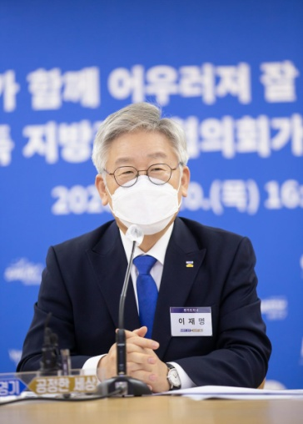 | 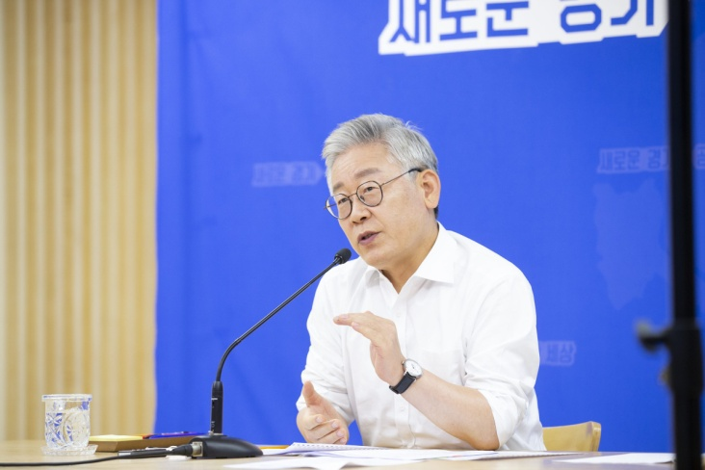 | 